Arithmetic Logic Shift Unit
Instead of having individual registers performing the microoperations directly, computer systems employ a number of storage registers connected to common operational unit called an arithmetic logic unit, abbreviated ALU.
The ALU is a combinational circuit so that the entire register transfer operation from the source registers through the ALU and into the destination register can be performed during one clock pulse period. Shift microoperations are performed in a separate unit.
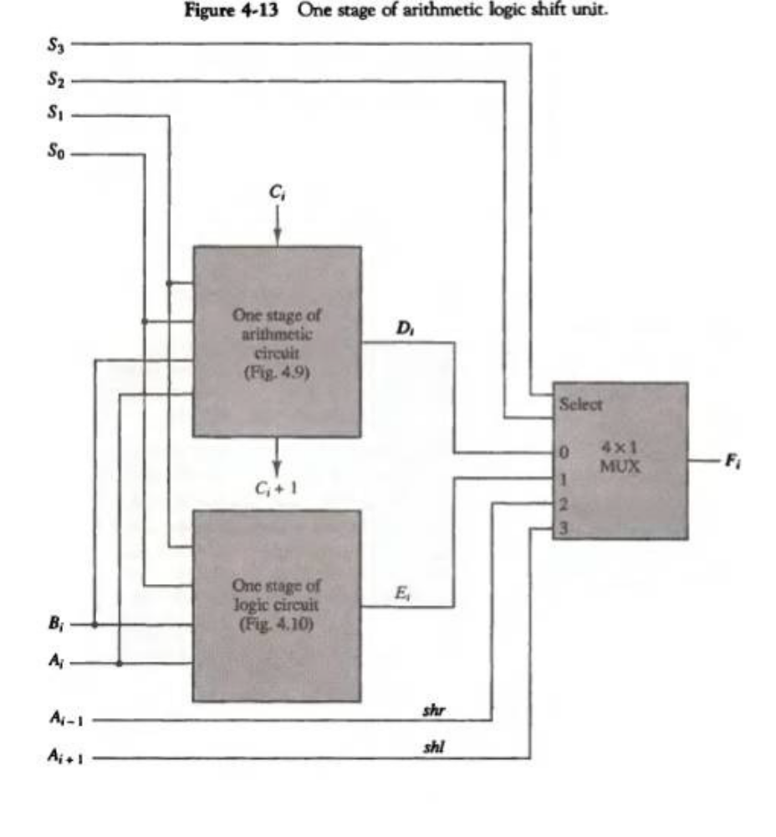
The arithmetic, logic and shift circuits can be combined into one ALU with common selection variables. Inputs A_{i} and B_{i} are applied to both the arithmetic and logic units. A particular microoperation is selected with inputs S₁ and S_{0.} A 4×1 multiplexer at the output chooses between an arithmetic output in E_{i} and a logic output in H_{i.} The data in the multiplexer are selected with inputs S₃ and S₂.
The other two data inputs to the multiplexer receive inputs A _{i-1} for the shift-right operation and A _{i+1} for the shift-left operation.
The output carry C _{i+1} of a given arithmetic stage must be connected to the input carry C _{in}, which provides a selection variable for the arithmetic operations.
The circuit in Fig. 4-13 provides eight arithmetic operation, four logic operations and two shift operations.
Each operation is selected with the five variables S₃,S₂,S₁,S₀ and C_{in}. The input carry C_{in} is used for selecting an arithmetic operation only.
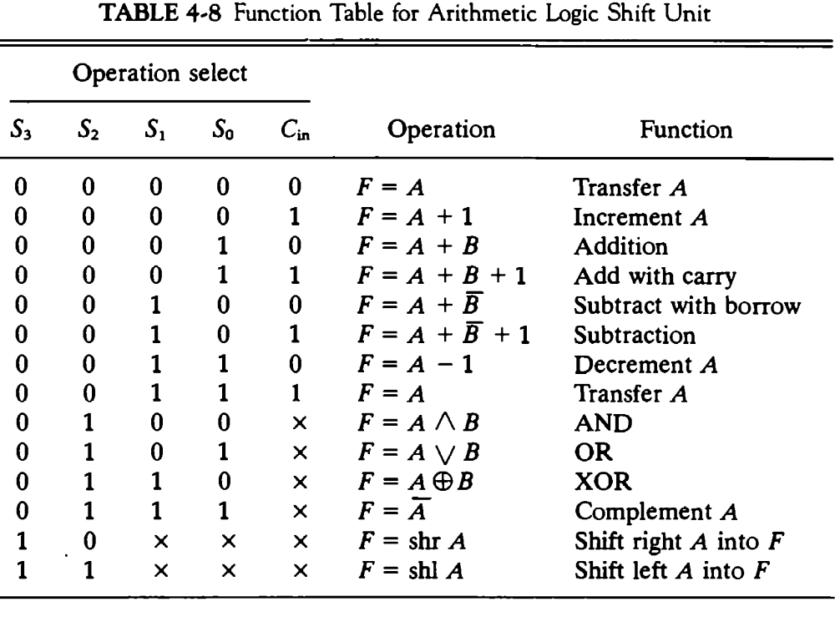
Table 4-8 lists the 14 operations of the ALU. The first eight are arithmetic operations and are selected with S₃S₂ = 00.
The next four are logic operations and are selected with S₃S₂=01.
The input carry has no effect during the logic operations and is marked with don’t-care X’s. The last two operations are shift operations and are selected with S₃S₂ = 10 and 11. The other three selection inputs have no effect on the shift.

